Open Sea 1520

Character Design Document

Vibha Alangar, August Dailey, Tyler Frantom, Aaron Michael, Jenner Wile

October 16, 2017

## **Hero**

### Overview

The Hero is the character that the player plays the game through. The player will be able to name the Hero whatever they want to and will be able to customize the way that the character looks at the beginning of the game.

Description/Looks

* Customizable name, gender, initial outfit, and hairstyle
* No set personality. The player can make this character act in any way wanted
  + Dialogue options allow the player to role-play

### Background

* Young adult who comes from the island of Malta in a small port town outside Valletta
* Lives with the mother character at the start of the game
* Dad was a famed adventurer who never came back from the last adventure
* Has an old love interest in Rome who they writes letters to and wishes to visit

### Relationships

* Loves mother and wants revenge for her death
* Looks up to the image of father
* Best friends with Jacob
* Marco is like a second father to the character, as well as the main mentor
* Hates Captain Red Jacket

## **Captain Red Jacket**

### Overview

Red Jacket is the main villain in Open Sea 1520, and the player’s first run in with him occurs after the player initially goes to Rome in the beginning of the story. Upon return, the player sees ships leaving and gets a glimpse of the Pirate Captain, wearing his signature burgundy jacket. Red Jacket is somewhat of a mythical character throughout the game, though he is the main villain. The player sees him occasionally while entering a port town and hears about him around the world.

### Description

* Main antagonist of the game, though he doesn’t know he is.
* Cold and professional in his piracy, it’s just a job to him.
* Has a cold and distant personality. He doesn’t care about anyone or anything.
* Is a mythical-like character to the Hero, since he had only been seen once and everything else is rumor.

### Looks

* Well built, though now too large of a man.
* Has dark brown hair and a large moustache
* Aged, soulless face
* Dark burgundy jacket over traditional seafaring garb.
* Cold expression

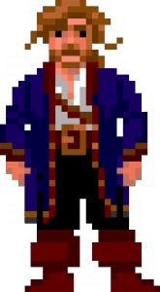

His clothes are similar to those pictured above, though the jacket is a dark burgundy and his hair is a dark brown.

### Background

* His backstory is unknown to the player until very late in the story
* He was a merchant sailor with a family in Florence. His family was killed by his debtors and he was forced into the start of his pirate career
* He decided that the world doesn’t mean anything to him long ago, and has been a cold killer ever since

### Motivation

* Piracy is the only thing he has left
* Wants to cause destruction all around the world
* Hates the world

### Relationships

* Jacob hates even the thought of Red Jacket
* Hero’s mother was killed by his crew
* Marco hates what he did to the Hero
* Barkeeps and merchants occasionally talk of him

## **First Mate (Jacob)**

### Overview

Jacob is the character that is the driving force of the Hero. Through his jealousy and disgust with the pirate crew, he constantly keeps the goal of redemption in mind.

### Description

* Constantly reminds Hero of the journey to confront the pirate villain

### Looks

* Well built, adventurous individual

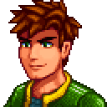

### Background

* Grew up in a small port town outside Valletta, Malta with the Hero
* Best friends with the Hero since they were babies
* Loves to explore
* Expert fisherman

### Motivation

* One day, the small port town outside Valletta was pillaged and burned to the ground by Captain Red Jacket’s crew. Jacob is driven by his emotions to one day destroy the same pirate crew that destroyed his town and the people in it.

### Relationships

* Best friend to the Hero
* Hates the Captain Red Jacket

## **Mother/Father**

Overview

The parents of our Hero are a huge influence in their life. The Hero values and respects their parents. The father is a major role model for the Hero, and provides a driving force for the Hero to keep moving forward.

### Description

* Parental figures dressed in age appropriate clothing
* Father is missing, assumed to be deceased
* Motivation for the player to take revenge upon the pirates

### Looks

* Mother has a long dress with a black apron
* Father is/was a sailor - large build, stern looking face
* Father can be seen in flashbacks

### Background

The father and mother are an important influence in the Hero’s life. The Hero grew up idolizing their parents. The father is a sailor, and passed his love of the sea and adventure on to the Hero. One day the father sets out to explore the surrounding islands, but a storm hits, and the father gets lost at sea. The ship comes back, thanks to the help of the father’s first mate. The first mate and the rest of the crew decide to stay on and be part of the Hero’s crew, and continue to offer guidance when necessary.

### Motivation

* Parental figures
* Provide motivation for the player - they come back, and see that their mother is dead. They want to avenge their parents death
* The player is also motivated by the father - he is the Hero’s idol and biggest role model

### Relationships

* Married to each other
* Mother/Father to the Hero
* Friends of the original crew

## **Love Interest (Angelo/Angela)**

## Overview

The Love Interest is the counterpart to the Hero, the one thing keeping the Hero in the Mediterranean. They are the reason to stay, and a reason to keep coming back to the Rome. Letters arrive at different points of time from the love interest to keep reminding the Hero to come back to Rome.

### Description

* Opposite gender of the Hero
* Located at the first port you travel to - used as motivation for the tutorial mission
* Male - Angelo
* Female - Angela

### Looks

* Female - akin to Leah from Stardew Valley. Not super flashy, just warm and inviting.
* Male - same as the Female Love Interest, not very flashy, just nice looking and comforting.

### Background

* Lived in Rome all their life, met the Hero during one of their trips into Rome with their father.
* Loves living in Rome, wants to convince the Hero to stay

### Motivation

* In love with the Hero, wants to keep them in the Mediterranean and live with them in Rome.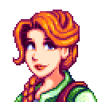

### Relationships

* Love interest of the Hero
* Butts heads with the First Mate

## **Ghost**

### Overview

Character that shows up the first night on the Hero’s boat. The ghost looks eerily similar like the father, but this is neither confirmed nor denied. This character offers both comic relief as well as occasionally a sense of guidance.

### Description

* Not a creepy/scary figure, just appears and disappears on a whim
* Appears on one of the first few nights on the ship
* Generally is a grumpy, snarky character

### Looks

* Face and build exactly like the father
* Grayed out, translucent

### Background

The ghost character looks suspiciously like the father, and it makes sense in the story - the father is lost at sea, and this ghost is on the father’s original boat. However, this is a conclusion that the player comes to on their own, as it is never explicitly stated.

### Motivation

The ghost character offers comic relief. He also, on the rare occasion, offers guidance. He usually has witty comebacks and snappy remarks to whatever is happening to the Hero. Most of the time, the Hero will just ignore what they say. On the very rare occasion that the Hero is at a loss on where to go or what to do next, the ghost will have some salient point to make that clears things up (can be used as reminder of gameplay mechanics).

### Relationships

* Offers comic relief to the Hero
* Occasionally offers guidance to the Hero
* Seems to like the original crew much more than any member of the crew that joins after the Hero starts their journey

## **The Kraken**

### Overview

The Kraken is a lesser character who the player will come across first in a small side mission, and then randomly throughout the travels.

### Look

* Very large, at least 150 feet tall
* Huge menacing head
* Body like a gigantic squid
* Blood Red in color

### Background

The Kraken is an ancient sea monster who is at least 2000 years old. Long ago, he made his home in a secret abyss in the Mediterranean. There he slept until he is awoken by the pirates accidentally and the player meets him first in a small mission to investigate an unsettling part of the water.

### Relationships

* Hero meets him on a quest and becomes a friendly yet neutral character
* Marco instantly becomes friends with him
* Jacob is terrified of him
* All other characters don’t really believe he’s real

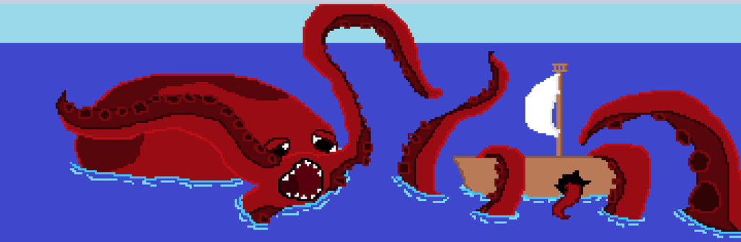

## **Barkeepers**

### Overview

Barkeepers are found in taverns in towns, selling drinks and keeping the peace. Barkeepers are firm and sometimes physically intimidating in order to stop people from causing a ruckus in their workplace.

### Description

* Barkeepers are the eyes and ears of the town, knowing some small bits and pieces of secret information in the town from people spilling their information while drinking

### Looks

* Big Strong Men
* Attractive Females
* Alternatively
  + Strong Women
  + Attractive Males

### Background

* Barkeepers are normally from the town that they work in

### Motivation

* Barkeepers are motivated to maintain their tavern
* Barkeepers are motivated to assist the Hero after completing a small task

### Relationships

* Helpful towards the Hero by providing missions and information

## **Merchants (Michael)**

### Overview

Merchants are found in their shop in every town, selling various goods specific to that town. The merchants in the game are all variations of one character - Michael, the quintessential, friendly, middle aged shopkeeper. Michael’s shop has the same sign in every port.

### Description

* Workaholic - spends most of their time in their shops
* Has various other family members based in different ports
* Will already know about the Hero from letters from their brothers

### Looks

* Happy, middle-aged man with a beard and a hat
  + Different hat at every port
* Large in stature, both in height and weight

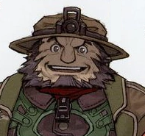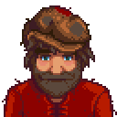

### Background

* Every merchant is a variation on Michael, but with a different hat. Michael will always talk about his brothers at other ports
* Dialogue makes the player think it might all actually be one person

### Motivation

* Make a fortune by buying and selling goods in their shop
* Make friends with travelers and stay connected with their brothers.

### Relationships

* Brother to every other merchant at other port
* Friendly to the Hero

### Possible Variations of “Michael”

* Istanbul - Mikail
* Venice - Michel
* Rome - Carmichael
* Tangiers- Mike (British)
* Tunis - Mikel
* Alexandria - Mikha’il
* Barcelona - Miguel
* Nice - Michal
* Athens - Michail
* Malta - Micah
* Havana - Miguelito

## **Shopkeepers**

### Overview

* Shopkeepers are one type of NPC that the player will meet in port
* Shopkeepers will trade with the player
  + Shopkeepers have more ordinary goods than Michael
* Shopkeepers occasionally give quests

### Description

* Provide a place to trade goods in the town
* Keeps stock of generic goods that differ from town to town

### Looks

* Shopkeepers will have an appearance consistent with the port they’re in
* Dialog will have some of the local dialect, but most dialect will be in english for the player’s convenience

### Motivation

* Shopkeepers want to make money by buying/selling goods with the player.
* Shopkeepers may also act on pride towards the port he’s in

## **Shipbuilders**

### Overview

Shipbuilders are one type of NPC that players will meet in port. Shipbuilders can be hired to upgrade the player’s ship, and occasionally give quests.

### Description

* Can repair/upgrade the Hero’s ship
* Has unique styles of ships available depending on the port

### Looks

* Shipbuilders will have an appearance consistent with the port they’re in. Shipbuilders will wear aprons and might carry tools
* Dialog will have some of the local dialect, but most dialect will be in english for the player’s convenience

### Motivation

* Shipbuilders want to make money by taking jobs from the player
* Shipbuilders also act on pride towards the port they are in and the work that they do

## **Port Authorities**

### Overview

Port authorities are one type of NPC that players will meet in port. Port authorities give quests, and will give the player historically accurate information about the port they are in.

### Description

* Act as the main quest givers for the Hero
* Gives small tidbits of information about the area

### Looks

* Port authorities will have an appearance consistent with the port they are in
* Dialog will have some of the local dialect, but most dialect will be in english for the player’s convenience

### Background

* Usually from the port they’re in, or else became really impressed with the port

### Motivation

* Port authorities want to show of the port they’re in, which they’re proud of

## **Village Idiot**

### Overview

Another character the Hero knows will be at every location. They provide comic relief to the Hero, and usually have some antics they are getting up to. Sometimes they have quests for the Hero as well.

### Look

* Dressed up like a court jester
* Hat with bells on it, makes noise
* Usually looks pretty goofy 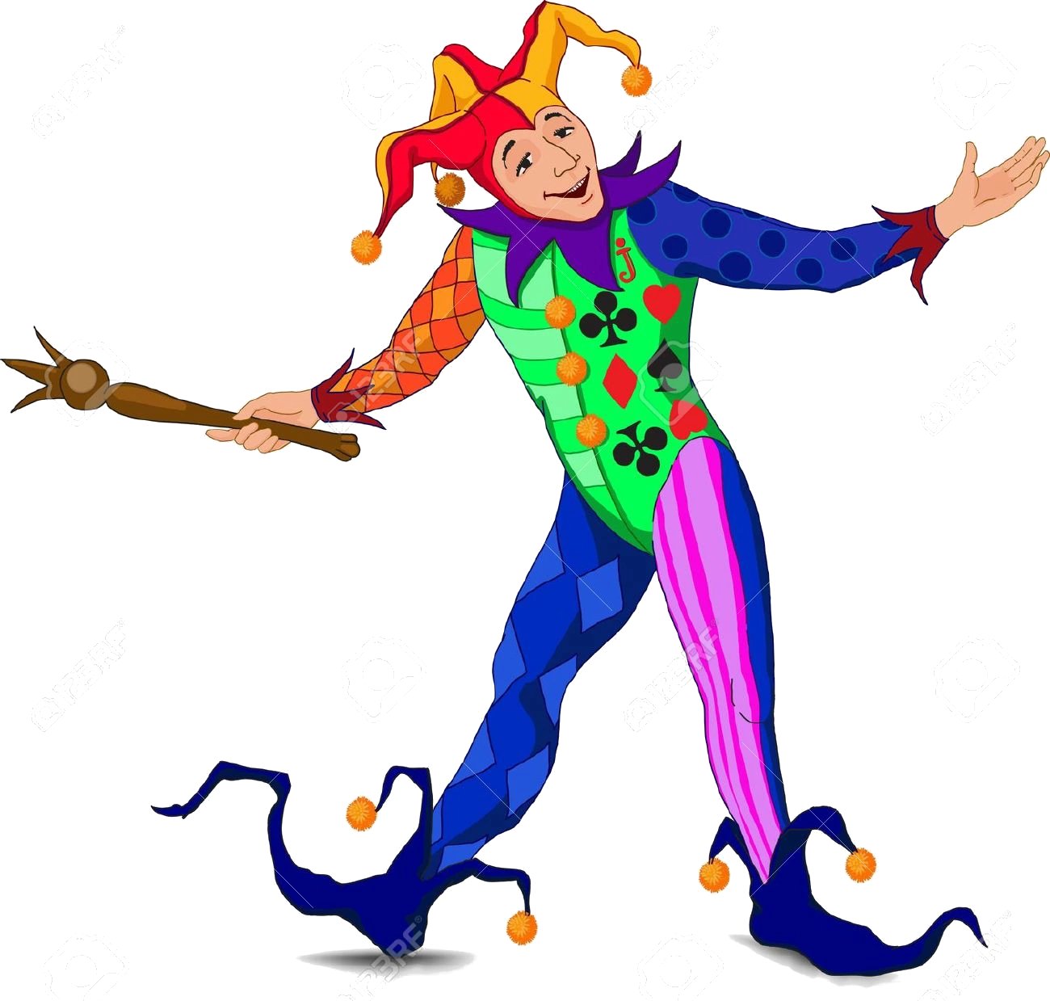

### Background

* No real backstory or background, they just appear randomly throughout the cities to cause mischief

### Gameplay

* Some village idiots will have small quests that involve helping them with their tom foolery, usually involving pranking another citizen

### Motivation

* Village idiots want to cause trouble in their cities, but are usually harmless.
* They add a bit of comic relief to the game

## **Sailors/Crew**

### Overview

Sailors are found around port towns, or as a result of quest lines. All sailors are able to join the Hero’s crew, if the Hero decides to recruit them. All sailors are randomly generated, with traits selected from port-specific lists (skin color, dress, hair color, etc).

### Description

* Rugged sailor-type person, male or female
* Randomized name (port and gender specific)

### Looks

* Port-specific dress
* Randomized features

### Background

* Very vague, just know them as a sailor looking to see the world
* Some sailors start with the first ship the Hero has. These sailors were on the Hero’s father’s ship, and decided to stay and travel with the Hero.

### Motivation

* Fame and Glory

### Relationships

* Friendly to the Hero

## **Pirate Crew**

### Overview

Pirates can be found randomly in ports causing mischief or trying to fit in with the crowd. Most of the time they are peaceful, but on the rare occasion there might be a mission to stop a group of pirates from creating havoc in a town or city.

### Description

* Pirates are placed throughout the game with intents to both hinder and fight the Hero in order to stop him from continuing onward

### Looks

* Pirates look burly and are very rugged, usually unshaved; some actually just lack the ability to grow beards
* They rarely care about the Hero’s desire to talk to them, just straight sassy

### Background

* Pirates are combative in that they can be fought at sea in ship battles, but at ports, they are just normal NPC’s who you can talk to

### Motivation

* Pirates are motivated by their desire to make their crew the best it possibly be, whether it's by pillaging for loot or defeating smaller crews

### Relationships

* Pirates associated with Captain Red Jacket
  + Provokes the Hero
  + Assists Captain Red Jacket as members of his crew
* Most pirates are just part of their own crew, separate from Captain Red Jacket
  + Provokes the Hero

## **Town Guides**

### Overview

At each city, there are famous monuments associated with that city. The player can go through the city to those monuments, and meet the town guide. The town guide will tell them a little bit about each of the monuments, and also give them a quest to complete. Sometimes these quests take place just in the city itself, and sometimes they require the Hero to go to other cities.

### Description

* Town guides are located in each city, near or around the famous monument of each city
* They’re relatively calm in demeanor, and they get excited about the city and monument

### Looks

* The town guides look like other NPC’s who you can talk to, but they are always standing around the monuments so the player knows who to look for
* They look pretty nerdy and scholarly

### Background

* Town guides are NPC’s that you can talk to, and they give out quests

### Motivation

* Town guides are motivated by their love of the history of the city they are in
* Their quests involve getting items from around the city, or from other cities so that the guides can learn more about the cities around them

### Relationships

* Town guides give the Hero an opportunity or reason to explore the city and surrounding cities

## **Marco**

### Overview

Marco is the mentor figure in the game, and is the person who brings the player their first ship and teaches them to sail.

### Description

* Happy, friendly, adventurous, middle aged man
* Loves the Hero like his own
* Thrill seeker

### Background

* Was the quartermaster on the father’s ship
* Old family friend of the Hero
* Started as a merchant in Venice
* Came to give the Hero their father’s ship and start their adventure

### Looks

* Average height with a slim build
* Weathered appearance
* Grayish hair
* Walks faster than all other characters
* Always has at least a smile on his face

Motivation

* Loves the Hero
* Wants to help the Hero start their own adventure
* Wants vengeance for his home town
* Dreams of adventuring again like when he was young

### Relationships

* Like a second father for the Hero
* Knows Jacob well and treats him like a son
* Family friend of the Hero, and hates Captain Red Jacket for what he has done

## **Animations/Gameplay**

### Sprites

* 8-bit style art
* Animation frames include walking and standing
  + Marco always walks slightly faster than others
  + Village Idiots always dance around instead of walk
* Shown from the front, sides, and back

### Portraits

* Main characters will have several portraits that show their emotion during the conversation
* Minor characters will have one portrait of themselves, will display when the Hero interacts with them
* All portraits are stationary, and appear over the text the character is meant to be speaking/thinking

The Kraken

* Stationary sprite while on screen
* When the player is near, the water around turns dark and the wind picks up

Battle with Captain Red Jacket

* Red Jacket’s ship will be much more powerful than any other pirate ships in the game
  + Higher cannon fire rate
  + Much more armor
  + More intelligent movements